Name: | ___________________________________________________ |  |  |  | Date: ___________
 | Year 11 Mathematics: Applications  Investigation 1, 2018  Topic – Forensic Science  Take home component
Important Information:
Although the take-home component is not worth any marks, it is essential in preparation for the in-class component. Knowledge and skills gained will be extended in the in-class validation component. This in-class validation will be completed under test conditions on the day in which this take-home component is due. The take-home component may be used when completing the in-class component. Contact may be made to parent(s) if the take-home component is not available for submission (at the start of the lesson).
Date out: |  | Week ____ Date _____________ | Date Due: | Week ____ Date _____________
Take home component weighting: |  | 0% of the year | In-class component weighting: | 10% of the Semester, 5% of the Year
AIM: In this assessment, you will be investigating how mathematics is used in solving crimes, through Forensic Science. You will be using your CAS ClassPad for this investigation, in particular the spreadsheet function.

Inspector Jack has been called to a burial site in Rockingham. Land sailors at Lake Walyungup have discovered some human bones, which have been identified as tibia, humerus and ulna. Inspector Jack thinks the bones are of the missing person Py Thagoras, a twenty-year old man who went missing five years earlier.
Dr Math is the Crime Scene Investigator (CSI) who has arrived to gather evidence.

Inspector Jack has asked Dr Math to describe how he can use the bones to determine the height of the body.

Dr Math explains that there are several rules that can be used to determine the height of the body. The formulas are different depending on whether the victim is male or female.

The table below shows these rules.
Height Estimation Equation | Male | Female
humerus (h) | H₁ = 3.08 h + 70.45 | H₁ = 3.36 h + 57.97
ulna (u) | H₂ = 3.70 u + 70.45 | H₂ = 4.27 u + 57.76
tibia (t) | H₃ = 2.52 t + 75.79 | H₃ = 2.90 t + 59.24

1. | Why are the rules for males and females different for each bone?

2. | For each of the following bones discovered, determine the height of the victim. Assume that the victims are all males.
a) | Tibia of length 45 cm | b) | Humerus of length 57 cm
c) | Ulna of length 31 cm

3. | For each of the following bones discovered, determine the height of the victim. Assume that the victims are all females.
a) | Tibia of length 38 cm | b) | Humerus of length 41 cm
c) | Ulna of length 28 cm

4. | Dr Math described a previous crime scene, where a man was found dead. Dr Math measured his humerus at  40 cm, his ulna at 34 cm and his tibia at 47 cm.
a) | For each bone discovered, calculate the predicted height of the victim.
b) | The police identified the victim as Carlos Sanchez, and discovered his actual height to be 195 cm. Comment on the accuracy of the predicted heights.

 | It can be annoying to enter the same rules into your calculator each time. You can use the spreadsheet function on your CAS calculator to enter formulas and compare results.
 | 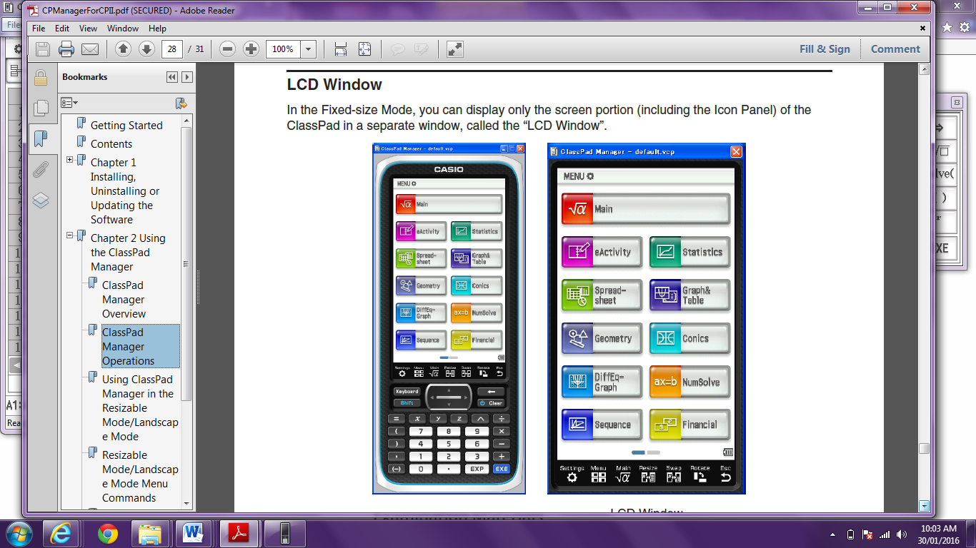  On the home screen, click on the Spreadsheet icon. | We are going to first look at the male bones.  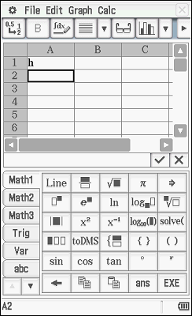  In the first column, in cell A1, type the letter ‘h’ and press EXE or . This is the humerus column. | In cell A2, type the number 1 and press EXE or . This represents a humerus of 1 cm.  In cell A3, type  =a2+1  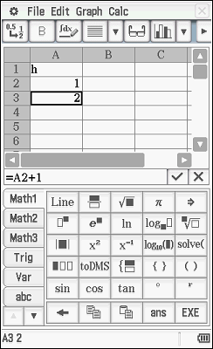  and press EXE or .
 | Click and hold cell A3 and then drag down to select a large number of cells. I have chosen to select to 101.  Next, press: Edit – Fill – Fill Range – OK  OR  Click on cell A3. Next, press:  Edit – Fill – Fill Range  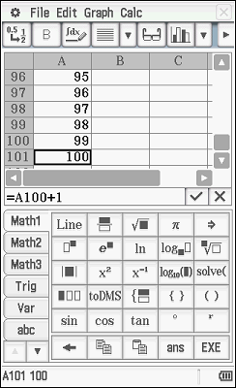  For the Range enter A3:A101 and then press ok. | Column B is going to be for the male height rule using the humerus.  In the second column, in cell B1, type the letters ‘mh’ and press EXE or .  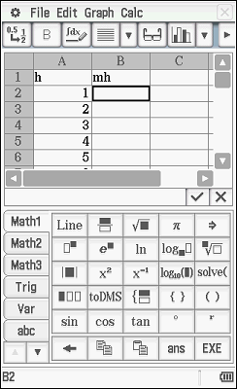 | In cell B2 type  =3.08×A2+70.45  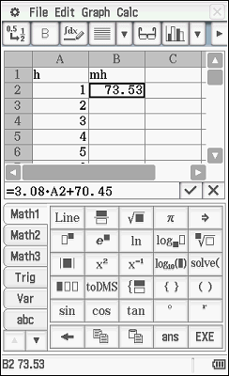  and press EXE or . A2 is referencing back to cell A2 which is our h value in the equation H₁ = 3.08 h + 70.45.
 | Click and hold cell B2 and then drag down to cell B101 to select cells.  Next, press: Edit – Fill – Fill Range – OK  OR  Click on cell B2. Next, press:  Edit – Fill – Fill Range  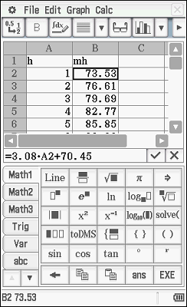  For the Range enter B2:B101 and then press ok. | We are going to now enter the data for the ulna.  In the third column, in cell C1, type the letter ‘u’ and press EXE or .  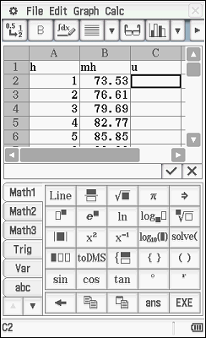 | In cell C2, type the number 1. This represents an ulna of 1 cm.  In cell C2, type  =C2+1  and press EXE or .  This will give you 2 cm.  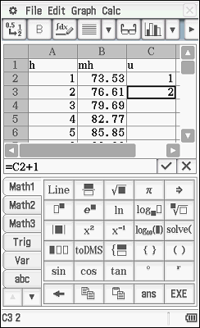
 | Click and hold cell C3 and then drag down to cell C101 to select cells.  Next, press: Edit – Fill – Fill Range – OK  OR  Click on cell C3. Next, press:  Edit – Fill – Fill Range  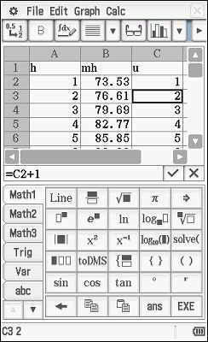  For the Range enter C3:C101 and then press ok. | Column D is going to be for the male height rule using the ulna.  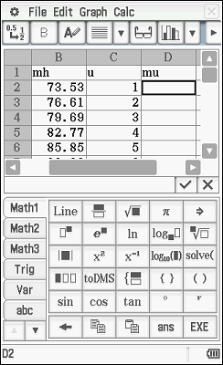  In the fourth column, in cell D1, type the letters ‘mu’ and press EXE or . | In cell D2 type  =3.70×C2+70.45  and press EXE or . C2 is referencing back to cell C2 which is our u value in the equation H₂ = 3.70 u + 70.45.  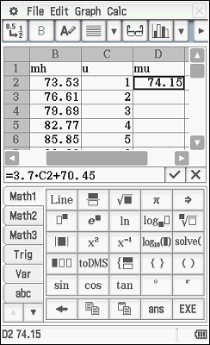
 | Click and hold cell D2 and then drag down to cell D101 to select cells.  Next, press: Edit – Fill – Fill Range – OK  OR  Click on cell D2. Next, press:  Edit – Fill – Fill Range  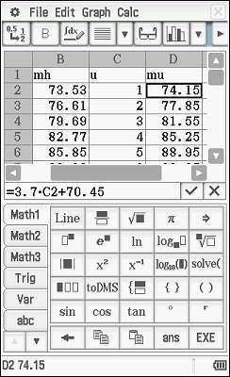  For the Range enter D2:D101 and then press ok. | We are now going to look at the tibia.  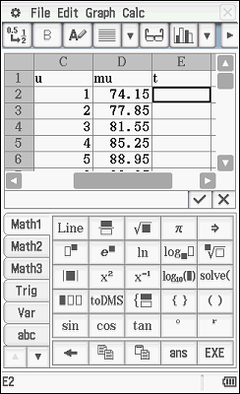  In the fifth column, in cell E1, type the letter ‘t’ and press EXE or . | In cell E2, type the number 1. This represents a tibia of 1 cm.  In cell E3, type  =E1+1  and press EXE or .  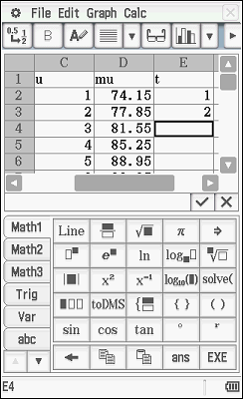  This will give you 2 cm.
 | Click and hold cell E3 and then drag down to cell E101 to select cells.  Next, press: Edit – Fill – Fill Range – OK  OR  Click on cell E3. Next, press:  Edit – Fill – Fill Range  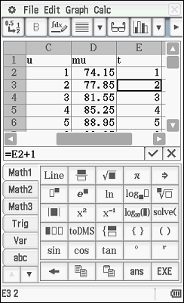  For the Range enter E3:E101 and then press ok. | Column F is going to be for the male height rule using the tibia.  In the sixth column, in cell F, type the letters ‘mt’ and press EXE or .  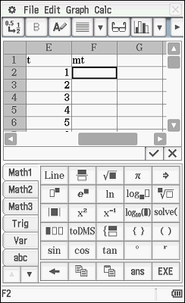 | In cell F2 type  =2.52×E2+75.79  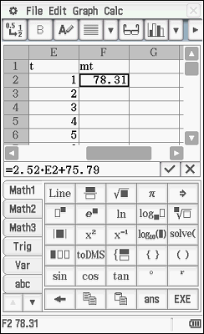  and press EXE or . E2 is referencing back to cell C2 which is our u value in the equation H₃ = 2.52 t + 75.79.
 | Click and hold cell F2 and then drag down to cell F101 to select cells.  Next, press: Edit – Fill – Fill Range – OK  OR  Click on cell F2. Next, press:  Edit – Fill – Fill Range  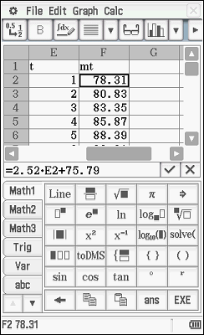  For the Range enter F2:F101 and then press ok. | Next, we are going to look at the female bones. To do this, we will need to export our variables h, u and t.  Press: File – Export  Variable is h  Type select List using downward arrow  Range is A1:A101  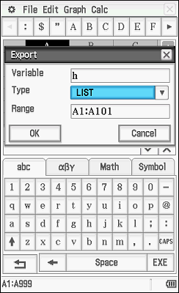  Press:ok | Repeat this two more times for variables u and t.  Press: File – Export  Variable is u  Type select List using downward arrow  Range is C1:C101  Press:ok  Press: File – Export  Variable is t  Type select List using downward arrow  Range is E1:E101  Press:ok  Save spreadsheet. Suggested name: Invest1M
 | We will now need a new spreadsheet page.  Press: File – New  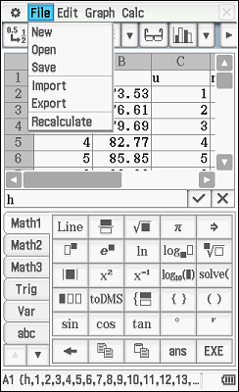 | As we have already defined the variables, our work setting up this spreadsheet is easier.  In the first column, click on cell A1. Press: File – Import  Variable is h  Cell is A1  Press OK  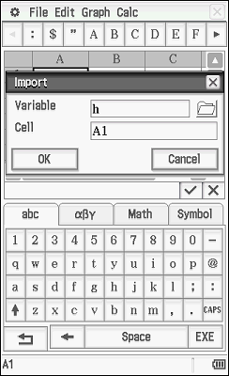  The data will automatically generate. | Column B is going to be for the female height rule using the humerus.  In the second column, in cell B1, type the letters ‘fh’ and press EXE or .  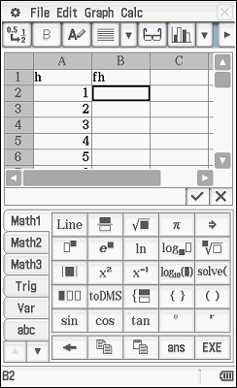
 | In cell B2 type  =3.36×A2+57.97  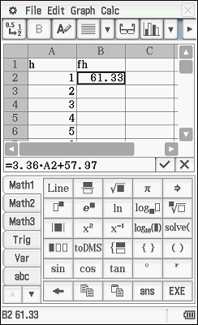  and press EXE or . A2 is referencing back to cell A2 which is our h value in the equation H₁ = 3.36 h + 57.97. | Click and hold cell B2 and then drag down to cell B101 to select cells.  Next, press: Edit – Fill – Fill Range – OK  OR  Click on cell B2. Next, press:  Edit – Fill – Fill Range  For the Range enter B2:B101 and then press ok.  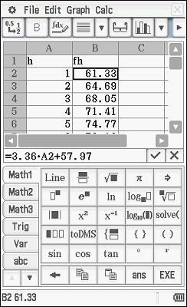 | In the third column, click on cell C1. Press: File – Import  Variable is u  Cell is C1  Press OK  The data will automatically generate.  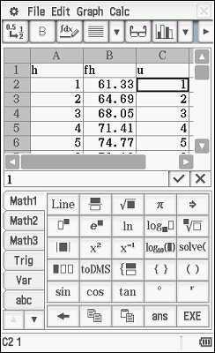
 | Column D is going to be for the female height rule using the ulna.  In the fourth column, in cell D1, type the letters ‘fu’ and press EXE or .  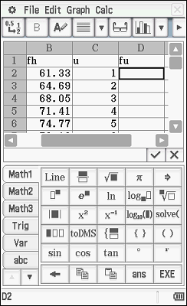 | In cell D2 type  =4.72×C2+57.76  and press EXE or . C2 is referencing back to cell C2 which is our u value in the equation  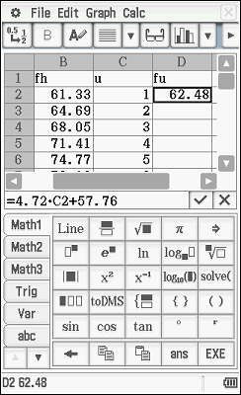  H₂ = 4.72 u + 57.76. | Click and hold cell D2 and then drag down to cell D101 to select cells.  Next, press: Edit – Fill – Fill Range – OK  OR  Click on cell D2. Next, press:  Edit – Fill – Fill Range  For the Range enter D2:D101 and then press ok.  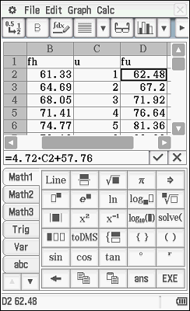
 | In the fifth column, click on cell E1.  Press: File – Import  Variable is t  Cell is E1  Press OK  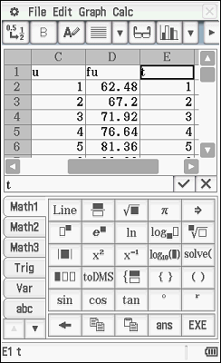  The data will automatically generate. | Column F is going to be for the female height rule using the tibia.  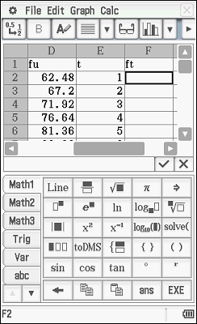  In the sixth column, in cell F1, type the letters ‘ft’ and press EXE or . | In cell F2 type  =2.90×E2+59.24  and press EXE or . E2 is referencing back to cell E2 which is our u value in the equation  H₂ = 2.90 t + 59.24.  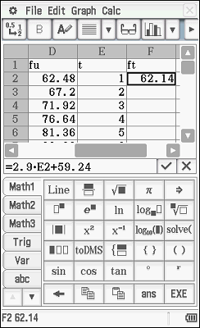
 | Click and hold cell F2 and then drag down to cell F101 to select cells.  Next, press: Edit – Fill – Fill Range – OK  OR  Click on cell F2. Next, press:  Edit – Fill – Fill Range  For the Range enter F2:F101 and then press ok.  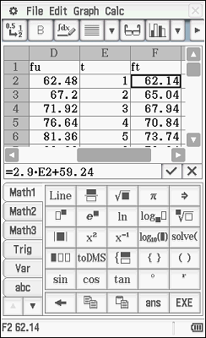 | Save spreadsheet. Suggested name: Invest1F.  You can change spreadsheets by pressing: File – Open and then selecting the spreadsheet you want to open.

5. | Using the male spreadsheet, determine the values in the following cells:
a) | B16 | b) | C28
c) | D81 | d) | F35

6. | Using the female spreadsheet, determine the values in the following cells:
a) | B27 | b) | A53
c) | D42 | d) | F77

7. | Using your spreadsheet, determine the length of each of the bones, if the male body was known to have a height of 185 cm. Give your measurements as the closest to the height.

8. | Using your spreadsheet, determine the length of each of the bones, if the female body was known to have a height of 163 cm. Give your measurements as the closest to the height.

 |  | When using the calculator you can create user-defined functions instead of having to type the formula in every time.
 |   On the home screen, click on the Main icon. |  | Press: Interactive – Define  Then in the dialogue box enter the following:  Funct name: mh  Variable/s: h  Expression: 3.08h+70.45  Press OK.  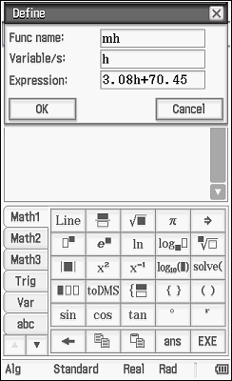 | You will need to repeat this process for all the equations.  Func name: mu  Variable: u  Expression: 3.70u + 70.45  Func name: mt  Variable: t  Expression: 2.52 t + 75.79  Funct name: fh  Variable/s: h  Expression: 3.36 h + 57.97  Func name: fu  Variable: u  expression: 4.27 u + 57.76  Func name: ft  Variable: t  Expression: 2.90 t + 59.24
Now you can use these shortcuts.
In the main (calculator) screen type
mh(1) then press EXE or .

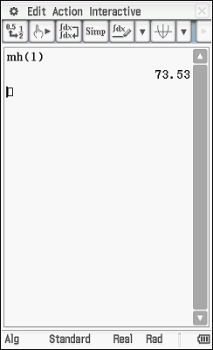

9. | Using the calculator page of your ClassPad calculator, determine the height of the following people:
a) | Male with an ulna of length 27 cm |  | b) | Female with an ulna of length 32 cm
c) | Male with a humerus of length 52 cm |  | d) | Female with a humerus of length 47 cm
e) | Male with a tibia of length 38 cm |  | f) | Female with a tibia of length 29 cm
10. |  | The following bones were recovered from the Lake Walyungup crime scene.
Bone Number | Type of Bone | Length (cm) | Sex | Calculated Height
1 | Humerus | 38.2 | Male
2 | Tibia | 38.9 | Female
3 | Ulna | 25.4 | Male
4 | Ulna | 31.8 | Male
5 | Humerus | 33.9 | Female
6 | Tibia | 44.5 | Male

a) |  | Complete the Calculate Height column.
b) |  | Is it possible any of these bones came from the same person? Which bones?
c) |  | What is the minimum number of bodies buried at this site?
d) |  | According to Py Thagoras’s medical records, he was 188 cm. Is it possible these bones belong to him?

11. | Two more bones were uncovered. One was an ulna bone and the other was a tibia bone.
a) | If it is known that the bones ‘belong’ to a female and the ulna bone is 30 cm long, who long should the tibia bone be?
b) | If the ulna bone is 28 cm long and the tibia bone is 39 cm long, predict whether the bones ‘belong’ to a male or female. Explain your reasoning.

